**DAY - 5**

**Class Exercise – 1:**

**package** com.test.test;

**import** org.openqa.selenium.By;

**import** org.openqa.selenium.WebDriver;

**import** org.openqa.selenium.WebElement;

**import** org.openqa.selenium.chrome.ChromeDriver;

**import** org.openqa.selenium.chrome.ChromeOptions;

**import** org.openqa.selenium.interactions.Actions;

**import** io.github.bonigarcia.wdm.WebDriverManager;

**public** **class** Day5_1 {

**public** **static** **void** main(String[] args) {

// **TODO** Auto-generated method stub

ChromeOptions co=**new** ChromeOptions();

co.addArguments("--remote-allow-origins=*");

WebDriverManager.*chromedriver*().setup();

WebDriver d=**new** ChromeDriver(co);

d.get("https://demoqa.com/droppable/");

d.manage().window().maximize();

WebElement drag=d.findElement(By.*id*("draggable"));

WebElement drop=d.findElement(By.*id*("droppable"));

Actions a=**new** Actions(d);

a.dragAndDrop(drag, drop).build().perform();

}

}

**OUTPUT:**

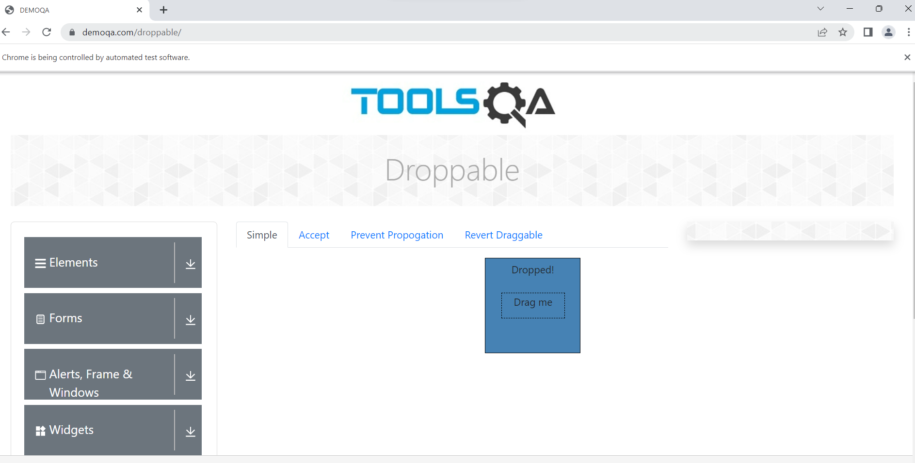

**Class Exercise – 2:**

**package** com.test.test;

**import** org.openqa.selenium.By;

**import** org.openqa.selenium.WebDriver;

**import** org.openqa.selenium.WebElement;

**import** org.openqa.selenium.chrome.ChromeDriver;

**import** org.openqa.selenium.chrome.ChromeOptions;

**import** org.openqa.selenium.interactions.Actions;

**import** io.github.bonigarcia.wdm.WebDriverManager;

**public** **class** Day5_2 {

**public** **static** **void** main(String[] args) {

// **TODO** Auto-generated method stub

ChromeOptions co=**new** ChromeOptions();

co.addArguments("--remote-allow-origins=*");

WebDriverManager.*chromedriver*().setup();

WebDriver d=**new** ChromeDriver(co);

d.get("https://jqueryui.com/droppable/");

d.manage().window().maximize();

d.switchTo().frame(0);

WebElement drag=d.findElement(By.*id*("draggable"));

WebElement drop=d.findElement(By.*id*("droppable"));

Actions a=**new** Actions(d);

a.dragAndDrop(drag, drop).build().perform();

}

}

**OUTPUT:**

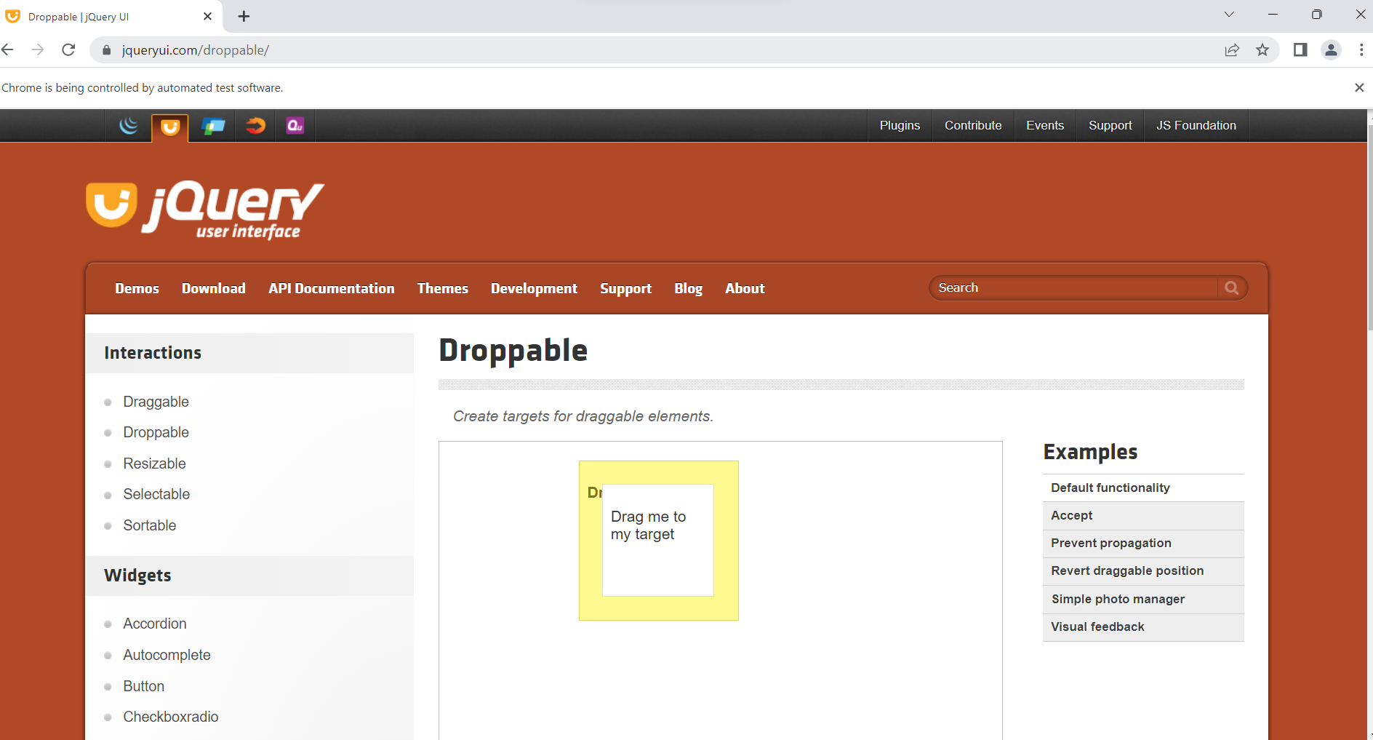

**Class Exercise – 3:**

**package** com.test.test;

**import** org.openqa.selenium.Alert;

**import** org.openqa.selenium.By;

**import** org.openqa.selenium.WebDriver;

**import** org.openqa.selenium.chrome.ChromeDriver;

**import** org.openqa.selenium.chrome.ChromeOptions;

**import** io.github.bonigarcia.wdm.WebDriverManager;

**public** **class** Day5_3 {

**public** **static** **void** main(String[] args) **throws** InterruptedException {

// **TODO** Auto-generated method stub

ChromeOptions co=**new** ChromeOptions();

co.addArguments("--remote-allow-origins=*");

WebDriverManager.*chromedriver*().setup();

WebDriver d=**new** ChromeDriver(co);

d.get("https://demo.guru99.com/test/delete_customer.php");

d.manage().window().maximize();

d.findElement(By.*name*("cusid")).sendKeys("401");

Thread.*sleep*(1000);

d.findElement(By.*xpath*("//input[@name=\"submit\"]")).click();

Thread.*sleep*(1000);

Alert a1=d.switchTo().alert();

a1.dismiss();

Thread.*sleep*(2000);

d.findElement(By.*name*("cusid")).clear();

d.findElement(By.*name*("cusid")).sendKeys("402");

Thread.*sleep*(1000);

d.findElement(By.*xpath*("//input[@name=\"submit\"]")).click();

Alert a2=d.switchTo().alert();

a2.accept();

System.***out***.println(a2.getText());

}

}

**OUTPUT:**

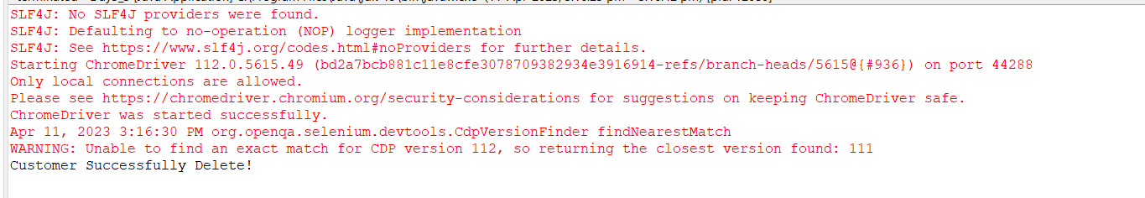

**Class Exercise – 4:**

**package** com.test.test;

**import** org.openqa.selenium.By;

**import** org.openqa.selenium.WebDriver;

**import** org.openqa.selenium.chrome.ChromeDriver;

**import** org.openqa.selenium.chrome.ChromeOptions;

**import** io.github.bonigarcia.wdm.WebDriverManager;

**public** **class** Day5_4 {

**public** **static** **void** main(String[] args) {

// **TODO** Auto-generated method stub

ChromeOptions co=**new** ChromeOptions();

co.addArguments("--remote-allow-origins=*");

WebDriverManager.*chromedriver*().setup();

WebDriver d=**new** ChromeDriver(co);

d.get("https://www.abhibus.com/bus-ticket-booking");

d.manage().window().maximize();

d.findElement(By.*name*("journey_date")).click();

d.findElement(By.*xpath*("//*[@id=\"ui-datepicker-div\"]/div[1]/table/tbody/tr[3]/td[4]/a")).click();

d.findElement(By.*xpath*("//*[@id=\"source\"]")).sendKeys("Coimbatore");

d.findElement(By.*xpath*("//*[@id=\"destination\"]")).sendKeys("Chennai");

}

}

**OUTPUT:**

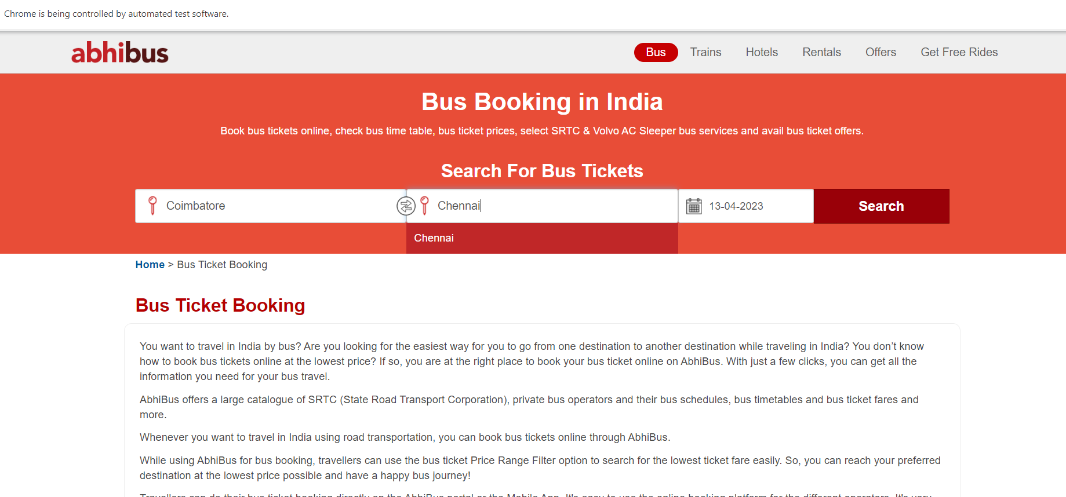

**Class Exercise – 5:**

**package** com.test.test;

**import** org.openqa.selenium.By;

**import** org.openqa.selenium.Keys;

**import** org.openqa.selenium.WebDriver;

**import** org.openqa.selenium.WindowType;

**import** org.openqa.selenium.chrome.ChromeDriver;

**import** org.openqa.selenium.chrome.ChromeOptions;

**import** io.github.bonigarcia.wdm.WebDriverManager;

**public** **class** Day5_5 {

**public** **static** **void** main(String[] args) {

// **TODO** Auto-generated method stub

ChromeOptions co=**new** ChromeOptions();

co.addArguments("--remote-allow-origins=*");

WebDriverManager.*chromedriver*().setup();

WebDriver d=**new** ChromeDriver(co);

d.get("https://www.google.com");

d.manage().window().maximize();

d.findElement(By.*name*("q")).sendKeys("Apple");

d.findElement(By.*name*("q")).sendKeys(Keys.***ENTER***);

System.***out***.println(d.getWindowHandle());

System.***out***.println(d.getTitle());

d.switchTo().newWindow(WindowType.***TAB***);

d.get("https://www.google.com");

d.manage().window().maximize();

d.findElement(By.*name*("q")).sendKeys("Selenium");

d.findElement(By.*name*("q")).sendKeys(Keys.***ENTER***);

System.***out***.print("\n"+d.getWindowHandle());

System.***out***.println("\n"+d.getTitle());

d.switchTo().newWindow(WindowType.***TAB***);

d.get("https://www.google.com");

d.manage().window().maximize();

d.findElement(By.*name*("q")).sendKeys("Cucumber");

d.findElement(By.*name*("q")).sendKeys(Keys.***ENTER***);

System.***out***.print("\n"+d.getWindowHandle());

System.***out***.println("\n"+d.getTitle());

}

}

**OUTPUT:**

